My Personal Board of Directors

Mentor?

________

Coach Kristen

________

Sponsor?

________

4word Mentor

Expert

Peer?

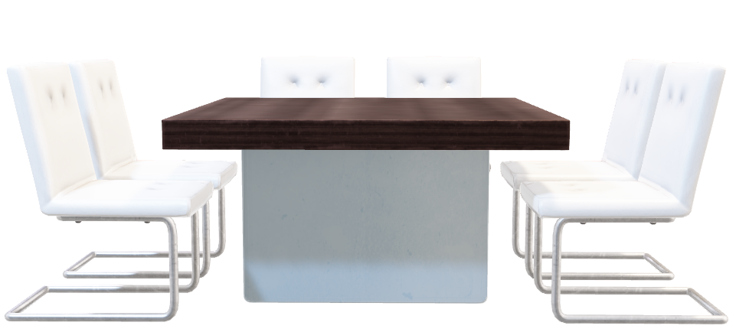

Faith